**Introduction**

This report includes an AC to DC converter design and producing steps in order to derive a DC motor. There are several topology in order to drive a dc motor such as 1-phase thyristor rectifier, 3-phase thyristor rectifier, diode rectifier with buck converter etc. This report includes comparison between these topologies. Advantages and disadvantages were considered when comparing the topologies. Also you can see design process of selected topology in detail in this report. Moreover, this report includes some simulation and their results in order to prove the performance characteristics of the driver. In addition to this, there is a thermal design in order to keep the temperature of the devices in the safe range. Finally, you can see cost analyze of the final product in the report.

**The DC Motor Specifications**

You can see the DC motor and its specification in the Figure 1 and Figure 2 respectively and its parameters below.

The motor's parameters:

* Armature Winding: 28 Ω, 13.3 mH
* Series Winding: 65 mΩ, 260 uH
* Shunt Winding: 8.26 kΩ, 6.4 H
* [Interpoles](https://www.quora.com/Electrical-Machines-What-do-interpoles-do-in-DC-motors) Winding: 0.8 Ω, 5.8 mH
* Inertia: TBA

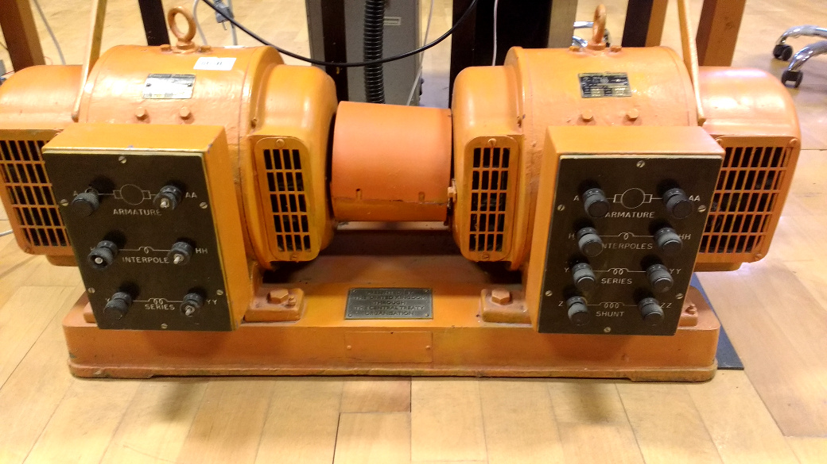

Figure 1: DC motor and generator set.

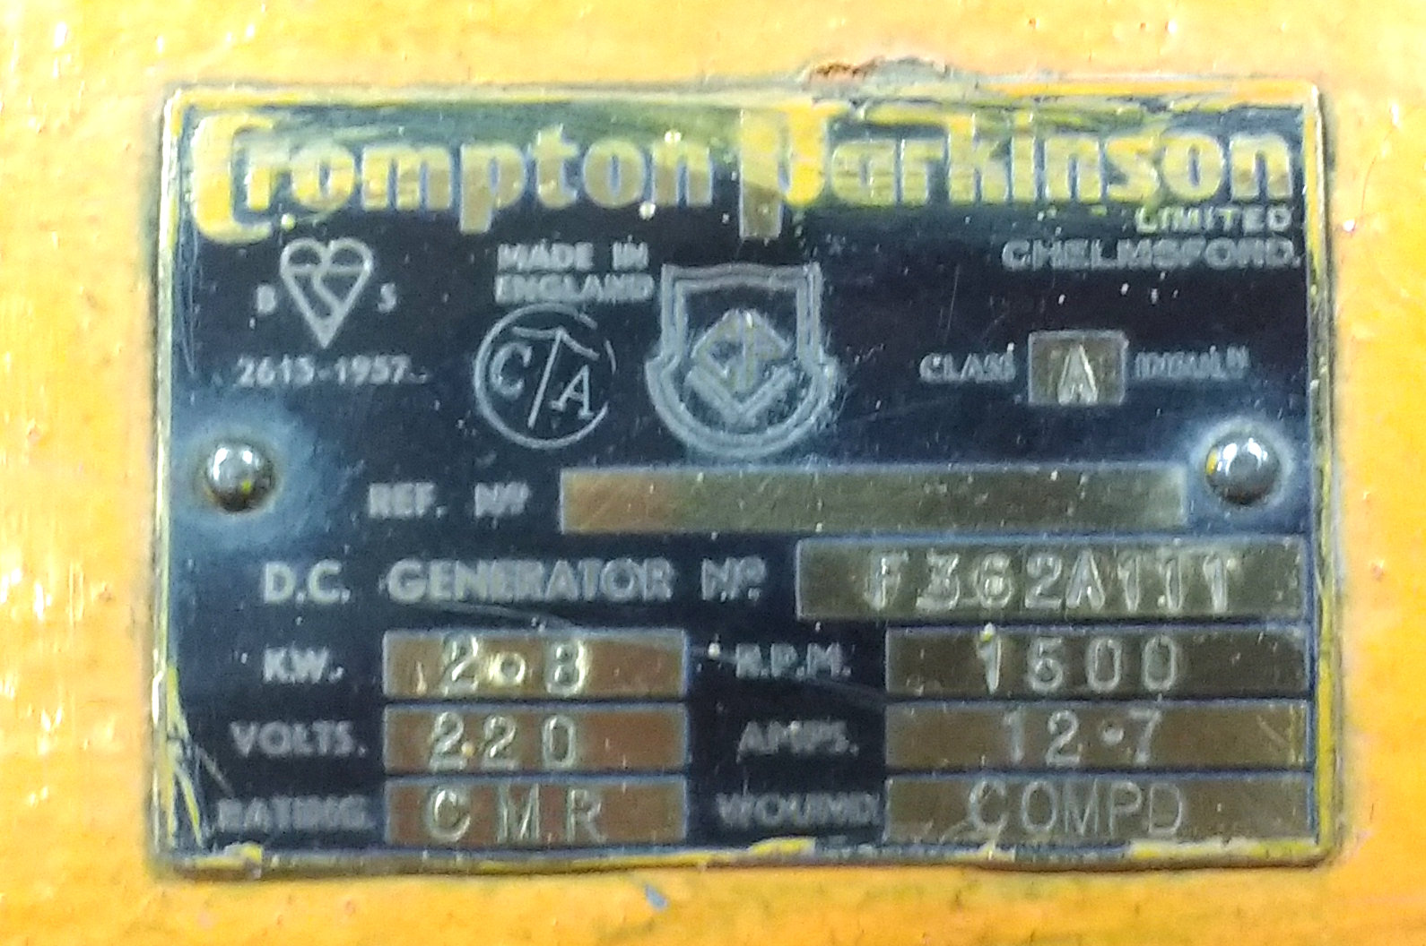

Figure 2: Motor template.

**Topology selection**

We considered 3 different topology which are 3-phase thyristor rectifier, 1-phase thyristor rectifier and diode rectifier and buck converter. We compared advantages and this advantages of each. You can see advantages and disadvantages of each topology in the Table 1.

|  |  |  |
| --- | --- | --- |
| Topology | Advantages of the Topology | Disadvantages of the Topology |
| 3-Phase Thyristor Rectifier | * Low output ripple than one phase thyristor rectifier * Higher output voltages than one phase thyristor rectifier | * need more thyristor than one phase rectifier * Cost is higher than one Phase thyristor rectifier * inject large harmonics into the utility system * When output voltage is small, power factor and displacement power factor is very poor. * producing notches in the line voltage waveform |
| 1-Phase Thyristor Rectifier | * less thyristor than 3 phase thyristor rectifier * Control circuit more basic than 3 phase thyristor rectifier | * Output voltages less than 3 phase thyristor rectifier * inject large harmonics into the utility system * When output voltage is small, power factor and displacement power factor is very poor. * producing notches in the line voltage waveform * You must use large capacitor to obtain low output voltage ripple |
| Diode Rectifier and Buck Converter | * You can control the switching frequency to reduce output voltage ripple * small filtering component | * When Ls and Ld are small, the current İd and is are highly discontinuous and there are very poor power factor at the utility * need more passive elements |

As you can see in the table 1 each topology has advantages and disadvantages. Firstly, we wanted to use small passive element in the output. Because of this we should have eliminated output voltage ripple as much as we can. So that, we eliminated the 1-phase thyristor rectifier even if 1-phase thyristor topology has less thyristor than 3-phase thyristor topology. After that, we wanted to use basic control unit in order to eliminate possible control circuit problem. Because of this we decided to use diode rectifier and buck converter topology even if it has more passive elements.